Maniototo Area School

Charter
2019
‘By learning we live’

TIMELINE:
BOT CONSULT: February 2019 SLT CONSULT: Jan/Feb 2019 STAFF CONSULT: Feb 2019
PARENTAL CONSULT: April-August 2019 WHANAU CONSULT: May 2019 MOE DEADLINE: March 1

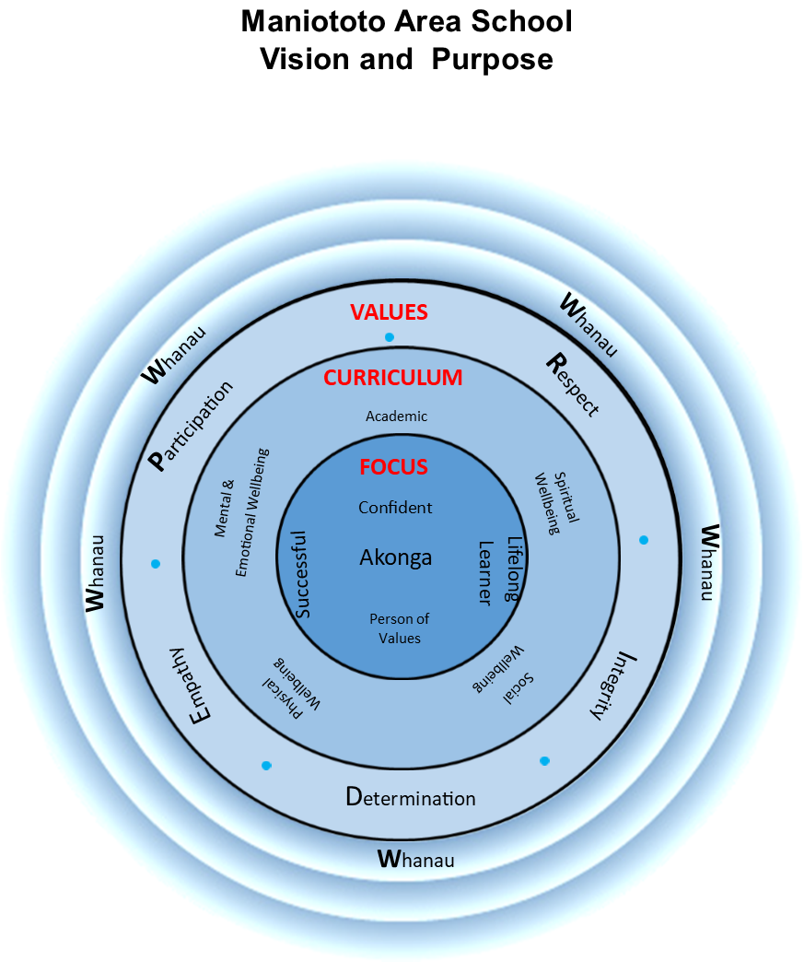

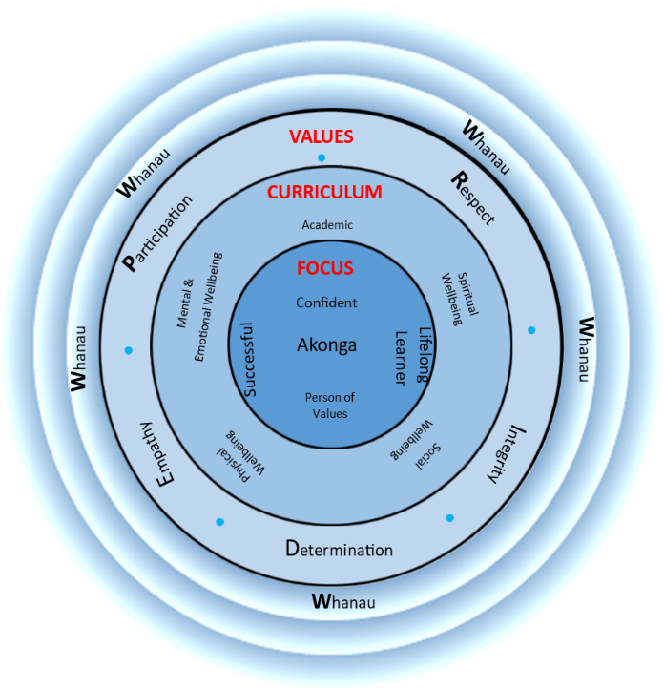
MANIOTOTO AREA SCHOOL STRATEGIC PLAN 2019
Mission -’Why we are here’
MAS students will recognise and strive to achieve their potential as skilled lifelong learners and positive, actively involved community members by upholding the school P.R.I.D.E values at all times.
Teaching & Learning
Quality teaching is the most important aspect of our school
Teachers encourage each student to reach their highest possible intellectual, practical, social and recreational abilities
Provide planned and varied learning opportunities in a challenging, caring & stimulating environment
Set high expectations, foster cooperation, responsibility and mutual respect.
Hauora
Provide a positive & safe environment where the physical & emotional needs of every student is cared for and nurtured
A socially inclusive school where all students feel safe and happy
Encourage students to be supportive of others and to keep themselves safe in the real & electronic worlds
Values—’How we live’
Our core values guide how we live, and conduct ourselves in our work and our relationships with others in the school. Specifically, our values are:
Participation
Respect
Integrity
Determination
Empathy
Vision—’Where we are going’
Through positive influence, example and efforts our students will:
Live the P.R.I.D.E values of the school
Become independent learners
Be confident risk takers
Have regular success
Enjoy school & learning
Be supported and encouraged to develop their physical, mental and emotional, social, and spiritual dimensions of health and wellbeing

Our Strategic Foci at MAS

External focus
Encourage & welcome interest, support and involvement of whanau
Promote school-community partnership
Foster understanding, appreciation and respect for traditional values of the Maniototo and promote good relationships among all cultures
Grow commitment to the Kahui Ako

LEVEL ONE: Mission—Vision—Values
UNPACKING OUR STRATEGIC PLAN
MISSION: Our Mission statement answers the question ‘Why are we here?’
VISION: Our Vision statement answers the question ‘Where are we going?’ and ‘What do we want to see in our learners?’
VALUES: Our Values relate to ‘How do we act?’. They set out the principles and standards we aspire to.
Our Strategic foci/goals stem from our Vision Statement. They answer the question ‘What are the most important objectives to the current and future health of Maniototo Area School?’

LEVEL TWO: Strategic Foci

Teaching & Learning
Teaching & learning is at the centre of what we do.
If we wish to improve outcomes for all students, we must focus on the relationship between the teacher, student, and content. The task that students complete show us how strong the connection is.
It is thus important that our systems and processes are strong and support teaching & learning, and wellbeing.
Our Theory of Action
IF we wish to improve outcomes for all learners
AND teachers have the greatest impact (Teaching matters)
THEN we must focus on instruction above all else

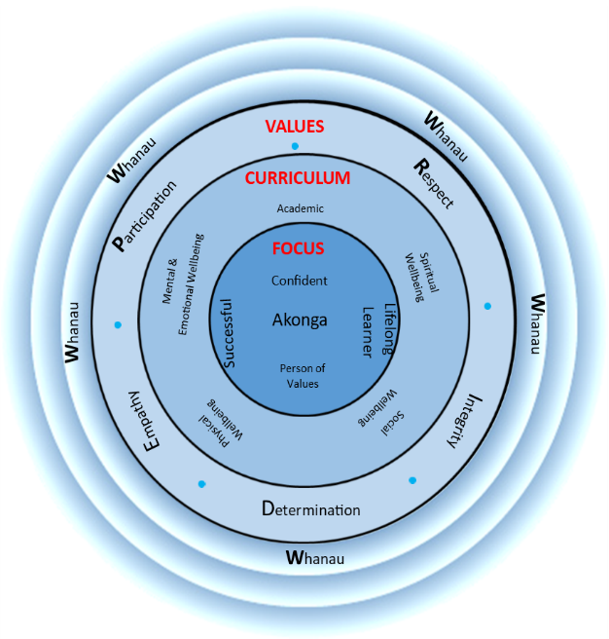
Hauora
In order to improve academic outcomes for all students, we must create a positive, safe, and supportive environment where every student feels cared for and nurtured. We believe that academic success and Hauora complement each other

External Factors
We are a community school. This means that we look to the whanau and the wider community to help us in achieving our mission and vision for all our learners. While being aware of the fact that external factors are quite often outside of the school’s control we value and appreciate school-community partnership.

LEVEL THREE: Annual Targets
Our Theory of Action
We believe that one or two informed and educated bets are better than simply hedging our bets with low-risk targets.
Each target must be based on evidence (why we need to do this).
So:
1. the target must focus on the instructional core
2. The target must relate to the other areas of focus
3. The target must address identified problems and be visionary at the same time.
4. Everyone takes ownership of the target

2019 Targets
Target #1: Teaching & Learning—What/Why/How
Writing (Yr.1-10): To have 85% of our students reach the expected curriculum levels in the following two aspects of writing:
⇒ Structure & Language
⇒ Punctuation

Target #2: Hauora—What/Why/How
Student Wellbeing: 90% of our students are able to share how they are feeling when they need to.

At Maniototo Area School we show PRIDE in the school and ourselves through:

Participation
Being cooperative and contributing.
Taking part with a positive attitude
Being reliable

Respect
Treating others the way you want/the way they want to be treated.
Caring for property & the environment.
Taking care of one’s own self.

Integrity
Being truthful to yourself, friends, whanau and community.
Being strong enough to do what is right.

Determination
Using your initiative & persevering when the going gets tough.
Committing to do the best we can.
Kia kaha - be strong

Empathy
Showing aroha towards others
Being kind and tolerant.
Being aware & considerate of people's feelings and culture.
Our Aims and Objectives

Curriculum Delivery | Our parent community believes quality teaching to be the most important aspect of a good school. Our teachers will encourage each student to reach their highest possible intellectual, practical, social and recreational abilities through planned yet varied learning opportunities within a challenging, caring and stimulating environment which motivates, sets high expectations, and fosters cooperation, responsibility and mutual respect. | Each year the principal and staff will develop, revise or confirm the curriculum plan in collaboration with the Board. The plan will include specific objectives for curriculum delivery, content, the maintenance of a safe learning environment, and the provision of appropriate guidance and career information for senior students.
Curriculum Content | To provide programmes that are responsive to the needs of the time and consistent with the national curriculum, while emphasising core skills of literacy and numeracy, effective communication, problem solving, critical and creative thinking, responsible decision making, and good citizenship. | The school’s curriculum plan will identify the purposes and key principles of assessing, recording and reporting on student progress and achievement. Emphasis will be on key competencies.
Student Progress  and Achievement | To regularly monitor and report each student’s progress, achievements and attitudes in ways that give dependable information about their strengths and next learning steps, enable shared communication and decision making between home and school about learning priorities and goals, and give feedback on the effectiveness and suitability of learning programmes. To increase student’s knowledge of their achievements and next steps | Junior School Students (Yr 1-8) have tracking sheets for Literacy and Numeracy. Achievement can also be seen on Edge. Students are assessed formatively and summatively and results used to plan programmes and report to parents. Reports are twice yearly. The monthly Attitude reports reflect key competencies through the P.R.I.D.E values and NZC. Yr 3-10 are diagnostically tested with e-asTTle and PAT early in the year and in some areas, re-assessed in Term 4. Year 11-13 are given constant feedback on NCEA progress during the course of the year, including practice exams, internal assessment results and through their strategic planners.
Student Hauora and wellbeing | To provide a positive and safe environment where the physical and emotional needs of every student is cared for and nurtured; an environment which actively seeks to create a socially inclusive school where all students feel safe and happy. To encourage students to be supportive of others and to keep themselves safe in both the real and electronic worlds. | Students are taught the importance of respectful relationships through specific programmes e.g. Kia Kaha and through P.R.I.D.E lessons. The school adopts a proactive stance against any form of bullying. Student feedback is recorded regularly. One period a week, viz. the P.R.I.D.E period is used to actively promote the school values.
Personnel | To be a good employer by acting with fairness and integrity in all employment matters; to promote high standards of staff performance; to support their ongoing professional development, training and conditions of work, and to recognise and value staff initiatives and actions that benefit students and the image of our school. | In consultation with staff, the Board will prepare policies and plans to appoint quality staff, to reflect its commitment to being a good employer, and to guide the operation of fair, effective performance management systems which enhance teaching and learning. Staff wellbeing is a priority.
Finance | To manage the school’s finances to meet current priorities and longer term goals for the operation and development of our school, and to achieve the best possible conditions and resources for teaching and learning. | The Board will prepare an annual budget to fund the school’s curriculum, personnel, and property and administration activities. The Board will monitor and control income and expenditure throughout the year, and ensure the preparation, audit and publication of annual accounts in line with public sector accounting requirements.
Property | To provide safe, hygienic and well maintained facilities which are suited to the needs of teaching, learning and living, and to plan and make improvements that meet the needs of a progressive curriculum and modern learning environment. | The Board will progressively upgrade learning environments to support modern pedagogical approaches, ensure compliance with the conditions of any current asset management agreement, and prepare and implement an on-going plan of property maintenance and development, including provision for safety and hygiene and meeting legislative requirements re hazards. This will be incorporated into the whole school rebuild due to begin in 2019.
Community Partnership | To encourage and welcome the interest, support and involvement of parents and the wider community in the life of our school and the well-being of our students, and to promote a school-community partnership which benefits from good two-way communications, co-operation, decision making and sharing of talents and resources. | The Board will have a policy with objectives for achieving parent-community support and involvement. The policy will be reviewed and reported on regularly, and revised as the need arises.
Cultural Diversity | To foster understanding, appreciation and respect for traditional values of the Maniototo, and to promote equality of opportunity and good relationships among all cultures represented within our community.  The Board will ensure that all reasonable steps are taken to provide instruction in tikanga Maori and Te Reo Maori for students whose parents request it. NetNZ and Te Kura will be used to provide secondary level programmes in Te Reo. | The school’s plans and policies will be developed and implemented in ways that are sensitive to the cultural backgrounds and values of individual children and their families. This includes recognition of the unique position of the Maori people and their culture.  Te Reo and tikanga Maori will be incorporated in school events, programmes and practices via REAP support and timetabled classes for Te Reo and Kapa Haka.
School  Self-Review | To regularly self-review the performance of the school in relation to this charter so that achievements can be recognised and priorities identified for school development and improvement.  The BOT will also use ERO Self-assurance statements for self-review. | The Board will have an annual time plan for the ongoing review of its plans and policies, ensuring that each plan and policy defines the procedures for its review. Reports from reviews will form the basis for deciding priorities for school development and improvement.
Special Needs | To offer an inclusive environment for learners with Special Education needs. The BoT will ensure that matters of access to learning and equity are taken into account. Where possible, special needs assistance will be given in the child’s own classroom environment. Groups of pupils with identified common needs may be withdrawn from a normal mainstream classroom for specialised instruction. | Individual Education Plans will be written for some children receiving special programmes of instruction. These will be co-written with parents, class/group teacher, Special Education representative (MOESE), Special Education Needs Coordinator (SENCO), Support personnel, Teacher Aides and Deputy Principals if appropriate.

Our Strategic Plan 2019-2021
We aim to… | How will this be addressed? | Who is Responsible? | Cost | Time Frame | Review
Safety  Provide an environment which is emotionally and physically safe. | Health Programmes – Hauora, Health curriculum  School values and key competencies  Teacher/student relationships  Restorative practices  Mentoring groups  Pastoral care focus  Use of student manager records  Community support agencies  PB4L  Kia Kaha | Principal  Staff  BOT  Students | Guest speakers:  Eg. John Parsons etc  Resource personnel  Eg. Stewart Hawkins | Ongoing | Survey – - annual (June)  Staff Students  BOT
Community  Create a community of learners, by building stronger links between family/whanau, students and school | Assemblies and performances  Deliberate formal and informal contact  Initial report and interview  Consultation events – hui  School website and Positively Maniototo articles  Notice boards and screen celebrating school events.  Passion Projects  P.R.I.D.E postcards  School Facebook page  Utilizing parent and community ability  Participation in community panels, groups  Links with ECE and other schools | Principal  Staff  BOT  PTA  Parent Community | Annual cost of Website $1200  Resourcing Outdoor Education equipment  Parent Portal | Ongoing | Principal  Staff  BOT
Uniqueness  Meet the unique needs of Area School Students and develop programmes that respond to these needs | Utilize teacher knowledge across school  Collaborative planning  Schoolwide events/house structure  Student led activities – school council  Use of local contexts and environments  Participation in and contribution to community events  VC virtual classrooms (NetNZ)  Participation in Area School tournaments  Establishment of and participation in the Southern Area Schools Community of Schools | Principal  Senior Leadership  Staff  Students  Principal, BoT of all 6 Area Schools  Staff | $500  $1000 | Ongoing  Ongoing | Staff  Y1-8 classes use inquiry model  As per agreed model with MoE  E Dean
Property  Develop plans for modern learning environment supported by ICT | Planning & Master Design for school rebuild  Create collaborative learning spaces using existing rooms with alterations  Develop long term strategy for property improvement & replacement  Develop sustainability & environmental awareness  Complete scheduled maintenance  Joint responsibility for pride in environment | Principal  BOT  Caretaker  Staff  Students  MoE appointed designers & advisers  Eg. Capital Works; TBIG; Baker & Garden Architects | Property consultants  $35,000  $40,000 | Ongoing | Annual BoT property subcommittee  Project Manager
Resourcing (ICT)  Resource the school so it meets the needs of 21st Century and Digital Learners | Increase numbers of computers in school making use of Wireless Technology  Introduce BYOD from Yr. 9 to Yr. 13.  School programmes and practices enhanced by efficiencies and opportunities of ICT. Increase ability to use SMS | Principal  BOT  ICT Leader | $15000 per year | Ongoing | Principal  Staff  ICT leader – annual evaluation
Values:  Create a teaching environment that is challenging, values learning and reflects the needs and achievement of the students.  Create Classroom environments that foster mutual and self respect, cooperation and understanding | Classroom maintenance  Classroom display of student work  Classroom replacement & refurbishment during school rebuild  Emphasis on positive Teacher/student Relationships  Playground and environmental development  School wide expectations  Health programmes & inquiry | Principal  Staff  Students  P.R.I.D.E team |  | Ongoing | Principal  Staff  P.R.I.D.E team
Holistic  For teachers to help students acquire key competencies through a range of contexts and:  teach problem solving and thinking skills  give priority to success in literacy and numeracy  (language,symbols,text)  allow for student directed learning(managing self)  promote physical activity  (participating,contributing)  give opportunities for artistic expression.  (participating,contributing)  To develop a consistently positive and supportive school environment by successfully implementing Tier 1 of PB4L and identify processes to increase engagement of at risk learners. | Inquiry opportunities for students  Collaborative teaching & learning  Goal setting by students  Self & peer assessment  Numeracy grouping in class  Reading grouping in class  Use of Teacher Aides & special programmes eg ALiM, STEPs  ICT integration  IEP’s for Senior students  Daily fitness and PE  Co Curricular sporting opportunities  Music/Dance/Performing Arts Opportunities  Student self-assessment of key competencies and targeted teaching of KCs  PB4L team to develop the framework and initiate the PB4L approach to pedagogy and behavior management | Principal  Staff  Students  Parents  Mentors  MoE – John Taylor  PB4L team  Staff, Parents, Students. | $6,000 | Ongoing  3-5 years | Principal  Staff  PB4L team

Realising Maori Potential

As a result of consultation with our local Maori community the following courses of action have been adopted to enhance Maori achievement at Maniototo Area School

- Ongoing monitoring and tracking of Maori achievement, but taking care when reporting data that individuals may not be able to be identified
- Ka Hikitia – using specific strategies that further enhance Maori achievement
- Ongoing teaching of Tikanga Maori in our Junior School and encourage students to be proud of their tikanga
- Sustaining and growing our Kapahaka group
- Encourage strong tuakana-teina relationships
- Teachers integrating Maori across all curriculum areas. Being aware of Maori perspective

2019
- Promote Te Reo using REAP kaiako, Whaea MaryAnne, continue & strengthen Kapa Haka
- Provide Te Reo instruction in Yrs. 7&8 and via NetNZ at NCEA levels
- Continue to focus on student achievement in line with consultation in 2015. Kahnohi ki kanohi consultation to refine goals and focus areas
- Continue and embed priorities previously identified.

Our Curriculum Annual Plan 2019
Target Area | How will it be addressed? | Responsibility Timeframe | Outcomes | Cost | Review
Years 1-10 Writing | At least 85% of our students will be at or above required levels. Improvements over previous years will be extended and consolidated. Ongoing moderation will support consistency of judgments. Teacher Aides will support identified students and groups.A more specific focus (e.g. focus on one deeper feature & one surface feature) will refine our approach | Year 1-10 Teachers  Lucia  Mid-Year check  &  End of Term 4 | To have 85% achieving at or above the curriculum levels. | Staffing and Teacher Aide Hours
Student wellbeing | At least 90% of our students will be able to say how they are feeling when they need to.  The 2018 Wellbeing Survey identified that 62% of our Year 9-13 students, and 32% of our Year 5-8 students felt that they couldn’t say how they were feeling. School wide total= 46%. This was the biggest issue identified in the survey. | Year 1-13 Teachers  PRIDE team  Mid year checkpoint  End of year check | 90% of our students will be able to say how they are feeling when they need to. | Restorative Practices Professional Development
Maori Target | Maori students who have been identified as Well Below will move two sub-levels in one or more of the following areas : Reading, Writing & Maths  Maori students in NCEA will gain Level 2 before they leave school. | Year 1-10 teachers  NCEA teachers  Lauren Becker | Maori students who are well below will move two sub-levels | Teacher Aide Hours
School-wide  Achievement of At Risk Students | Continued participation in our Kahui Ako. Team approach to improving success rates for at risk students and other goals that the Kahui Ako works on each year.  ‘Flexitime’ has been introduced (usually in T2 of the year) to enhance the IEPs that have been set up for the senior students. The use of Strategic Planners and mentors too will be continued.  Consolidation of Tier 1 PB4L will help develop strategies to engage at risk or underachieving students | Kahui Ako  Teachers  Ongoing | Risks to student achievement will be identified earlier and all teachers will have access to information in all subject areas. Area School teachers will pool expertise  Leadership team will use data to guide improvement | Indeterminate (see annual budget) | Principal  Leadership Team as per MoE
Year 11-13  NCEA Target | 90% of our Year 11-13 students will attain the NCEA level they are attempting. Detailed goals will be developed with students and their families.  We will increase the proportion of students having endorsements in merit or excellence and the numbers of credits passed at merit or excellence  Stronger, clearer course guidance and earlier engagement of families /whanau. | Senior NCEA Teachers  Term 1-4 | Students and whanau will have shared understanding of student goals and programmes  Success rates will improve to 90% success overall |  | Deputy Principal & Principal
Year 7-13  Student Health and Well Being | To focus on students’ awareness and development of the Key Competencies and the school P.R.I.D.E values.  Support goal setting and achievement  Support anti cyber bullying programme to keep it visible in the school and community | Year 7-8 Homeroom & Health Teachers  Year 9 -13 Tutor Teachers, mentors  Terms 1 -4 | Students will have enhanced relationships with teachers and each other.  Year 10 students will be supported to develop key competencies. | Relief time for any PD | Principal

Our Property & Finance Annual Plan 2019

Target Area | How will it be addressed? | Responsibility/Timeframe | Expected Outcome | Cost | Review
Property redevelopment | A master plan that meets the needs of the school and priorities of the community will be developed.  Plans will include teaching areas that cater to all learning and teaching needs, and enhanced outdoor teaching areas. | TBIG, Capital Works and Baker & Garden Architects  End Term 3 | Agreed plan for redevelopment will be completed | To be determined)
Property management | Playground hazards of lack of safety surfaces and further tree trimming will be prioritized.  The Horticulture section will be further developed | BoT Property  End T2  SLT team  Mid Term 4  Alec | Risks from trees minimized  Resource for horticulture established | TBC
Annual Accounts and Annual Audit | Annual account, including variance report completed by due date for approval and audit | Executive Officer  Principal | Public sector accounting expectations will be met
Financial Reporting | For finance subcommittee to prepare monthly reports for BoT that shows financial performance and financial position. | Treasurer  Principal  Executive Officer | BoT will have clear understanding on which to base decisions. Priorities will be funded
School Fees/Donations | Ensure that processes are clear, easy to follow and comply with public sector guidelines for schools and Ministry directives | Executive Officer | Maintain current rates of payment of donations and fees

Our Community Annual Plan 2019
Area | How will it be addressed? | Responsibility/Timeframe | Outcomes | Cost | Review
Reporting to Parents | Reporting: Report schedule reviewed and initial report includes student self-assessment, goal setting and parent input.  Process for establishing OTJ’s refined and clarified for parents/family. (Ongoing)  Inclusion of summaries of school wide and departmental data in school newsletters  Monthly Attitude Reports to parents through Edge | Principals and Teachers  Term 1  Leadership teams  Term 4  Teachers  Term 1 and 2 | Improved communication and partnership  Families better informed  OTJ’s that are accurate and defendable known by parents  The relationships between home and school | TBC
Parent Meetings | Increase the proportion of families attending meetings. Deepen the level to which families are consulted with and have input.  Review changed schedule for usefulness and manageability  Introduce ‘Meet the Teacher’ evening where students share their goals with their teachers and parents present. (Term 1) | Principal and teachers  Term 1 wk 5, T2 wk 9, T3 Yr 11-13 only  T4 wk 7  T4 wk 8 Yr 9-10 | Tataiako implementation progressed
School Publicity | Screen in foyer showcasing width & depth of curriculum  Newsletters, Notice boards, articles in Positively Maniototo  Burn Radio  School Facebook page and website  Development of publicity flyers for Year 7/8 students | Principal  Staff  Students | Ongoing | TBC
Community Consultation | Maori community consultation  Regular ‘small surveys’ to evaluate school programmes and events  Kanohi ki kanohi – take opportunities to ask families/whanau their opinions  The community will be consulted about the property master plan  Area-wise consultations with the SMT going to the areas rather than asking parents to come to school | Principal via Lauren & Staff Term 2  BOT & Principal  SMT | Increased whanau understanding of Neg requirement and knowledge of student achievement. | TBC | BOT

Our Personnel Annual Plan 2019
Area | How will it be addressed? | Responsibility Timeframe | Outcomes | Cost | Review
Appraisal | Appraisal system aligns with legislative requirements and incorporates RTC, professional standards and the school priorities – shifted to Jan to Dec cycle. Done online through Arinui | Principal  Deputy Principals  Term 1-4 | Good practice will be shared and spread | $100 per staff
Professional Development | All teachers will participate in on-going development of PB4L pedagogical knowledge,  In 2019 Restorative Practices will be formally introduced to our current PB4L framework. | Leadership Team  In-school Kahui Ako tr. | Increased awareness and consistency of practice | TBC
Personal Professional Development | Staff will develop their own personal development plan that is part of the performance management system and aligns with school goals. All PLD will be related to the goals in the personal plans & Kahui Ako  Year 0-10 to continue to investigate ways of improving Writing,Maths and Reading teaching and learning programmes.  Teachers’ personal inquiries based on Kahui Ako cohort groups and topics | Principal  Teachers | Aligned systems will support good teaching practice. PD will support teachers own goals |  | Varied, needs consolidation
Good Employer | Board review feedback from surveys to ensure and assess staff morale and wellbeing | Board of Trustees (T3) | Improved staff morale
Allocation of Units | Develop a procedure for the designation of units and of school structure (rotation of fixed units biennially) in consultation with staff. | Principal  Deputy Principals  Term 1 | Allocations will align with school priorities
Kahui Ako Teamwork & Change | Teachers will be supported and encouraged to be responsive to change and to become a more unified team across the Kahui Ako. Senior teachers will increase joint responsibility for student achievement and success – holistic approach that is student centred.  CoL participation will address identified challenges  Team effort in SLC supervision and monitoring  Collaborative teaching in Yrs. 2 to 8 | Principal  Senior leadership team  In-School teacher

Our Governance Strategy of Self Review

 | Year 1 - 2019 | Year 2 - 2020 | Year 3 – 2021
Term 1 | Annual Plan  Assessment and Reporting  Community Consultation – property redevelopment  English  NCEA results analysis  Kahui Ako – Area Schools community | Annual Plan  Support Programmes – including ESOL, Reading Recovery, STEPs, ALiM  NCEA results analysis  English  Kahui Ako - | Annual Plan  S.I.E.P (2017)  English  NCEA results analysis  Visual Arts & Music  Kahui Ako-
Term 2 | BOT Self Assurance - Curriculum & Plan  Science  Visual Arts & PB4L  Maori Community Consultation | BOT Self Assurance - hauora & welfare  Science  Agriculture | Science  Woodwork & Graphics & Woodwork  BOT Self Assurance - Asset Management Ctte  Community Consultation - property redevelopment
Term 3 | BOT Self Assurance Finance Ctte  Social Studies & Mathematics | Technology  BOT Self Assurance Health,Safety & Welfare Ctte  Social Studies  Mathematics & PB4L | Mathematics  Social Studies  Careers  BOT Self Assurance Kahui Ako
Term 4 | Horticulture & Tourism  Reading/ Writing (Yr. 1-10)  Strategic Plan 2020 | Strategic Plan 2021  Physical Education, Health & SENCO  Reading/Writing (Yr. 1-10) | Careers, Tourism, EOTC  BOT Self Assurance Finance Ctte  Strategic Plan 2022

2019 BOT MEETING DATES (proposed)
Term 1 Wed 13 February & We 20 March
Term 2 Wed 22 May & Wed 26 June
Term 3 Wed 24 July & Wed 21 Aug
Term 4 Wed 23 October & Wed 20 Nov

Our Policy Review Cycle
Maniototo Area School has now moved online with School Policies on Schooldocs (www.schooldocs.co.nz)
School policies will be reviewed as per the notifications given by Schooldocs.

 | Policy | Who to consult | 2019 | 2020 | 2021
NAG 1: CURRICULUM | Curriculum & Student Achievement  EOTC  Health Education/Curriculum consultation  Home Learning  Improving Educational Outcomes for Maori  Learning Support  Reading Recovery/Literacy Support  Recognition of Cultural Diversity | Board/staff  Board/staff/parents  Board/staff/parents  Board/Staff/parents  Board/Staff/parents  Board/Staff/parents  Board/Staff/parents | review  review  consult  assurance | consult  review  assurance  review | review  review  assurance
NAG 2:  DOCUMENTATION & SELF-REVIEW | Documentation & Self-Review  Reporting to Parents  School Planning & Reporting | Board  Board/Staff/parents | submit | review  submit | review  submit
NAG 3:  EMPLOYER RESPONSIBILITY | Appointment Procedure  Appraisal of Staff  Appraisal of Principal  Attestation  Classroom Release Time/ Timetable  Complaints  EEO Policy  Employer Responsibility  Performance Management  Police Vetting for Non-Teachers  Protected Disclosure  Provisionally Certified Teachers (PCTs)  Salary Units/Management Allowances  Staff Leave  Teacher Certification and Police Vetting | Board  Board/Staff  Board/Staff/parent  Board/Staff  Board/Staff  Board/Staff  Board/Staff  Board/Staff | assurance  assurance  assurance  assurance  assurance  review  assurance  assurance  assurance | review  assurance  assurance  assurance  review  assurance  review  assurance  assurance  review  review  assurance | assurance  assurance assurance  assurance  review  assurance  assurance  review  assurance  assurance
NAG 4:  FINANCE AND PROPERTY MANAGEMENT | 10 Year Property Plan (10YPP)  Finance and Property Management  Financial Control and Expenditure  SUE (Staff Usage and Expenditure | Board  Board | assurance  review  assurance | assurance  assurance | assurance  review  assurance
NAG 5:  HEALTH, SAFETY, AND WELFARE | Abuse Recognition and Reporting  Alcohol, Drugs, and Other Harmful Substances  Behaviour Management  Child Protection  Digital Technology and Cybersafety  Emergency Planning and Procedures  Evacuation Procedure/Emergency Kit  Harassment  Health, Safety, and Welfare  Medicines, Minor/Moderate injury or illness  Physical Restraint  Risk Management  Safety Management System  Separated Parents, Day-to-Day Care, & Guardianship  Sun Protection  Surrender & Retention of Property and Searches  Visitors | Board/Staff/parents  Board/Staff/parents  Board/Staff  Board/Staff  Board/Staff  Board/Staff  Board/Staff  Board/Staff/parents  Board/Staff | assurance  review  assurance  review  assurance  review  assurance  assurance  assurance  assurance  review  assurance | assurance  review  assurance  assurance  assurance  assurance  assurance  assurance  review  assurance | assurance  review  assurance  assurance  review  assurance  assurance  assurance  assurance  assurance  review
NAG 6:  LEGISLATION AND ADMINISTRATION | Length of School Year  Privacy  Student Attendance | Board | assurance  assurance | assurance  review  assurance | assurance  assurance

AREAS OF RESPONSIBILITY February 2019 :
Any member may attend any meeting
Committee | Convenor
Professional Ethics | Chairman | Principal  Staff Rep
Appointments/EEO | Principal  EEO Officer | Rose Voice  Belinda Colling  Alastair Watt  Staff Rep
Property/School Houses | Alastair Watt (School)  Rose Voice (Houses) | Principal  Chairman  Craig Paterson
Health & Safety | Principal | Chairman  Staff Rep  Alastair Watt
Finance | Chairman | Principal  Executive Officer  Craig Paterson
Curriculum | Principal | Staff Rep  Student Rep  All Board Members
PTA | Jenna Huddleston | Staff Rep  Quinton Smith  Belinda Colling
Policy | Principal | Chairman  Staff Rep  Belinda Colling  Alastair Watt
School Rebuild | Chairman | Principal  Craig Paterson  Quinton Smith  co-opted member

In accordance with Section 64 of the Education Act, the Maniototo Area School Board of Trustees undertakes to take all reasonable steps to achieve the purpose, aims and objectives in this charter which have been approved by the board following consultation with the community in terms of Sections 61 and 63 of the Education Act, and to take full account of the National Education Guidelines and all statutory obligations.
The Board of Trustees accepted this charge as its undertaking to the Minister of Education on (Ratified in minutes).
This charter was submitted to the Ministry of Education for the Minister's approval on 27/2/2019
Chairperson. Board of Trustees .Date 2019

For Minister of Education

ANNEX A:CODES OF CONDUCT

Effective governance and management is a successful blend of community involvement and professional competence. The Board of Trustees agrees to adhere to the following Code of Conduct.

BOARD OF TRUSTEES
In carrying out their responsibilities, members of the Board will:

- Ensure that the needs of the students and their learning are given full consideration when planning, resourcing and implementing the school’s curriculum.

- Ensure that all students are provided with an education which respects their individuality and challenges them to reach the highest standards of personal achievement.

- Serve their school and their community to the best of their ability and be honest, reliable, trustworthy, loyal and fair.

- Act with fairness and integrity in all matters concerning staff, the Principal, parents and students.

- Maintain the confidentiality and trust vested in them.

- Ensure strict confidentiality of papers and information related to the Board’s position as employer.

- Ensure that individual trustees do not act independently of the Board and its decisions.

- Accept that the Principal is the professional leader of the school and responsible in the first instance to the Board.

PRINCIPAL
In carrying out his or her duties, the Principal will:

Ensure that the needs of the students and their learning are given primacy in planning, resourcing and implementing the school’s curriculum.

Show commitment to the belief that each student is of equal value and is entitled to an education which respects their individuality and challenges them to reach their highest standards of personal achievement.

Be loyal to the Charter and fully committed to achieving its purpose, aims and objectives.

Act fairly and with integrity in all matters concerning staff, members of the Board of Trustees, parents and students, and show a commitment to the continuing development of the staff’s professional skills.

Work cooperatively with school staff, but take final responsibility for decisions within the Principal’s authority as delegated by the Board.

Provide all information on a student to any person with legal rights to the information who requests it, and respect confidentiality by keeping information on students from people who have no right to it.

Not vote in Board of Trustees’ decisions in relation to the Principal’s employment.

